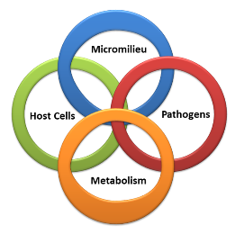
Application form
RTG 2740 Immunomicrotope

Personal data
First name | Family name
Date of birth | Place of birth
Gender (m, f, d) | Nationality
Address | E-mail address
Postal code | City
Country | Phone
Education
High school (name, city, country) | Date | Grade
University training (name, city, country) | Time period | Subject/Faculty
Master degree (e.g. M.Sc.) in | Date | Grade
Previous degree(s) (e.g., B.Sc.) in | University | Grade

Major field of Master studies

Title of Master thesis

Short description of Master project

Supervisor (name, address, phone number)

Acquired laboratory skills and knowledge
Methods

Additional research experience (e.g., internships)

Legal permission for animal testing procedures (e.g., FELASA)

Additional skills
Languages (proficiency level according to Cambridge certificate or TOEFL)

Further skills and interests (including scientific and non-scientific interests)

Awards and scholarships
Publications
Preferred RTG 2740 research project (Please state project number)
1.

2.

3.

How did you find out about our job advertisement?
- DFG (German Research Foundation)
- PhD Germany (DAAD)
- FAU
- AiD Newsletter (KoWi)
- German Society for Immunology
- German Society for Hygiene and Microbiology
- Indeed
- Jobvector
- Advertisements
- Information by mentors
- other_________________

